Faculty of engineering

Computer and system engineering dep.

Cs22: computer and society project

MEMORY GAME

(FIND THE PAIR)

* Doctor:

SAHAR M.GHANEM

* Programmers' name:

SARA MUHAMMAD YOUSSEF ENAS MORSY MOHAMED

WELCOME TO OUR PROJECT

WISH YOU ENGOY PLAYING IT!!

**1. Description of our game:-**

It’s a game that requires player to spot the identical pairs in each level .match pairs of shapes together with the help of your memory

It is a game which aims finding all matching pairs of pictures. At start all pictures are face down, click the boxes to uncover them if the last pictures don't match, the will again turn face down, repeat till you uncover all the pairs.

**2. OVERVIEW OF THE DESIGN:-**

* **The game has 3 levels easy, medium and hard.**

**Easy level (6x6): 18 pairs**

**Medium level (6x7):21 pairs**

**Hard level (6x8):24 pairs**

* **There are 2 buttons the START one to start the timer and to start a new game , the second one is the SOLVE one to uncover all pairs.**
* **For each level we have 3 files HTML, CSS and JS.**
* **We have the main web page RUN which also has 3 files.**
* **The timer is paused when the player solve the game or all pairs are found together.**
* **When the pairs are found the audio plays!!!**

**3. DATA STRUCTURES:**

**3 arrays 1. arr [] to store the links to the pictures.**

**2. arr2 [] to store the links to audios.**

**3. index [] to store digits refers to images.**

**4. USED FUNCTIONS:**

* New pic (): to print the image.
* shuffleArray(): to rearrange the images randomly.
* checkPair(): to check if the player opened the correct pair.
* Solve (): to uncover all the pairs.
* Start (): to let the timer works.
* CountTimer (): to calculate hour, min and sec print them.

**5. USER GUIDE:-**

* **Choose which level you want to play.**
* **Click on start button to see the timer.**
* **If you want to uncover the images, click on solve button.**
* **If you find a correct pair, wait to listen to music.**
* **To start a new game, click the start button again.**
* **To choose another level you should go back.**

**6. IMAGES:-**

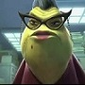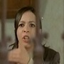

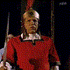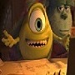

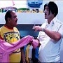

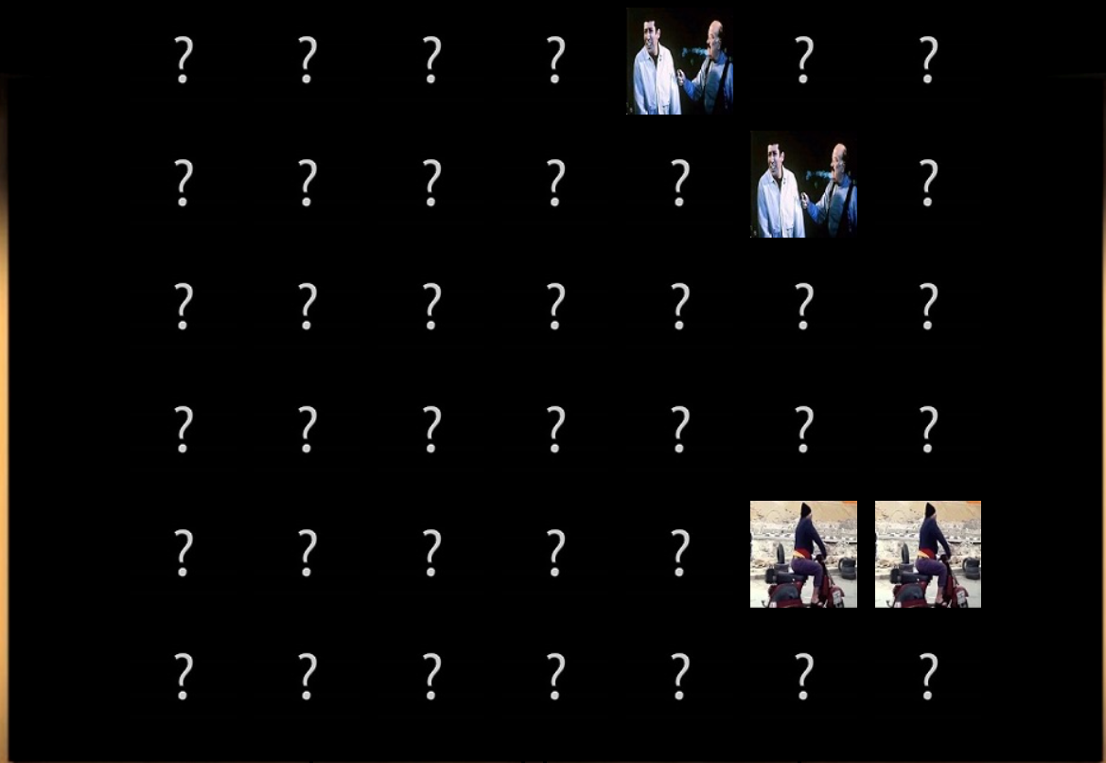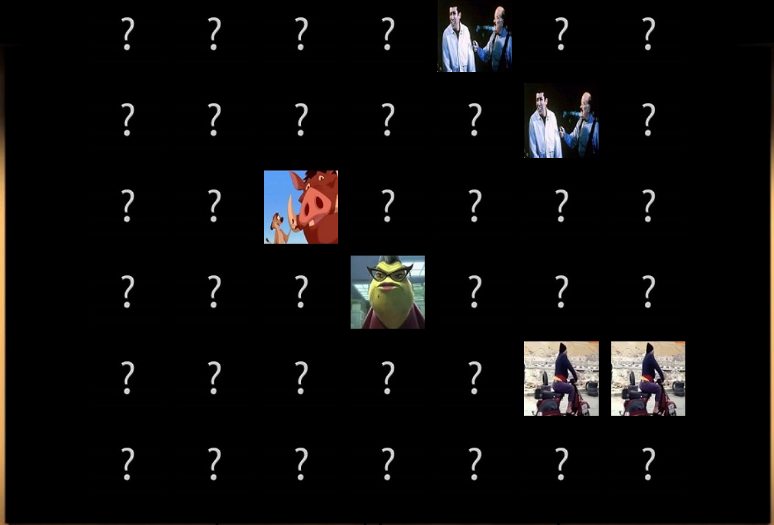7. SAMPLE RUNS:1.

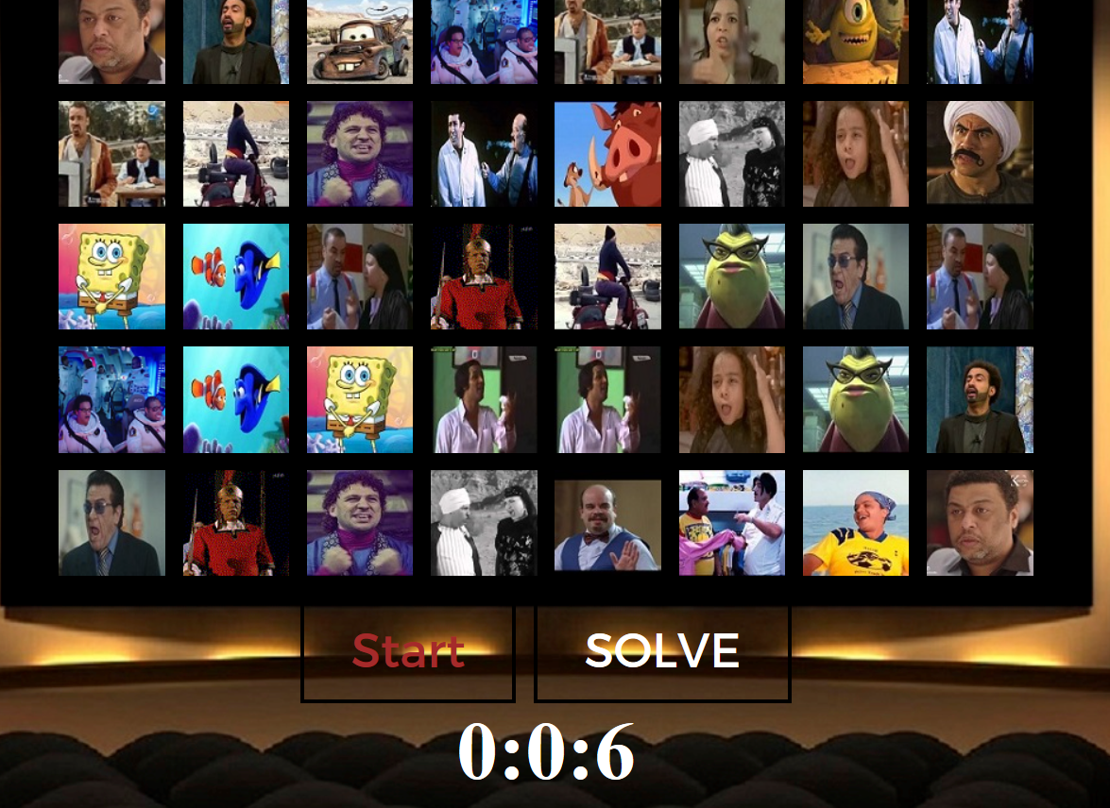2.

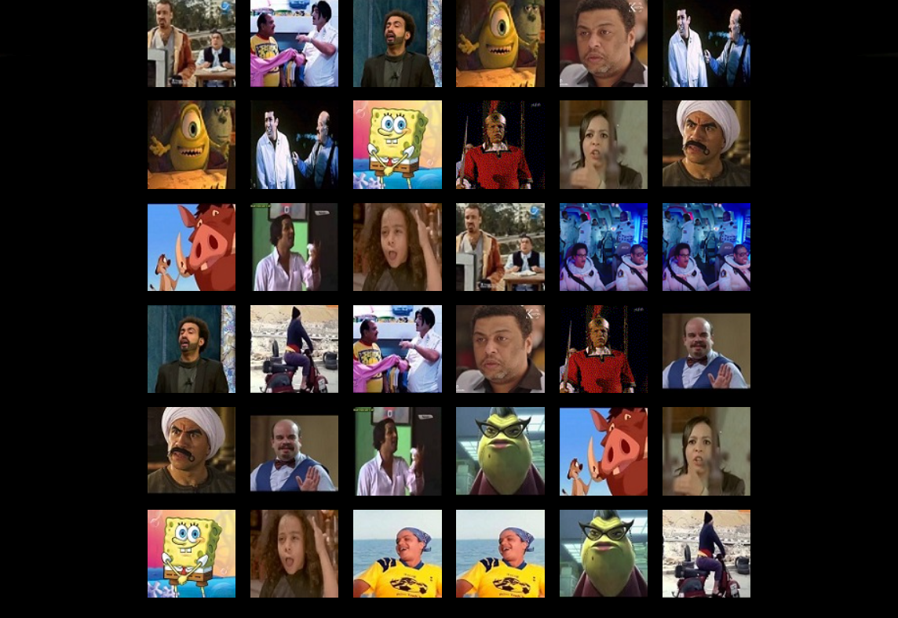3. solve button

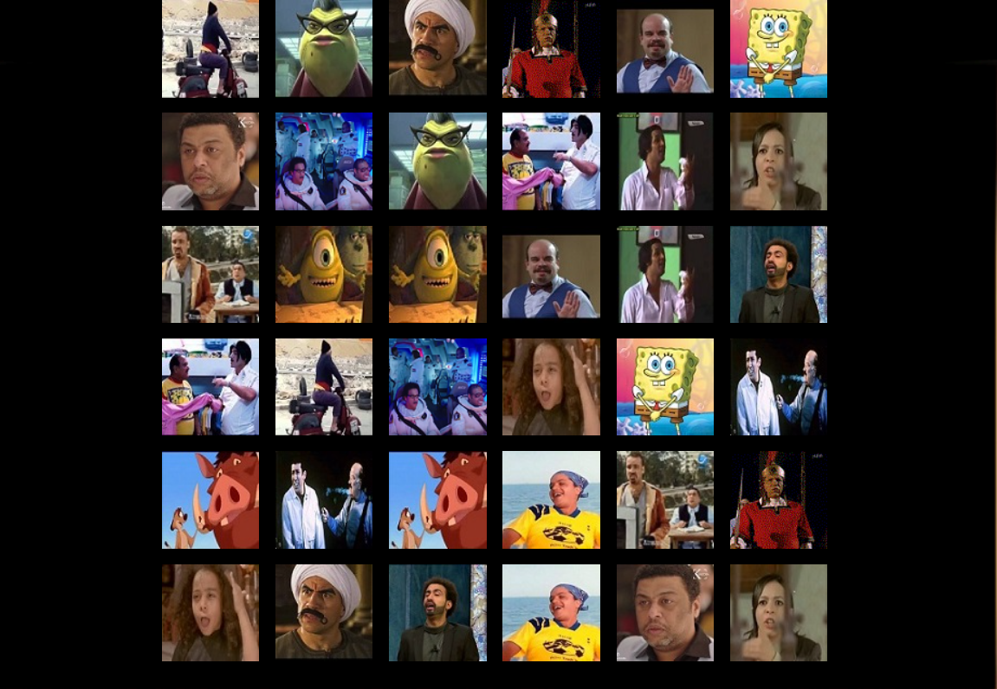 Start again /solve again